Steps to create an AWS Lambda function-

1. Open up the Lambda Console and click on the Create button.

Be mindful of where you create your functions since Lambda is region-dependent.

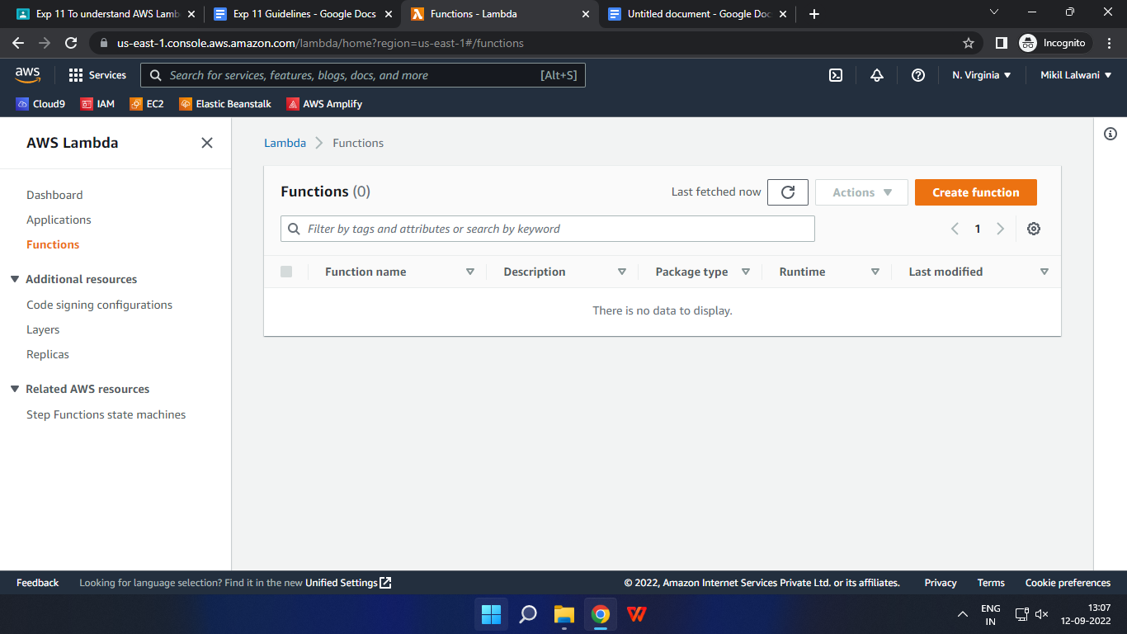

1. Choose to create a function from scratch or use a blueprint, i.e templates defined by AWS for you with all configuration presets required for the most common use cases.

Then, choose a runtime env for your function, under the dropdown, you can see all the options AWS supports, Python, Nodejs, .NET and Java being the most popular ones.

After that, choose to create a new role with basic Lambda permissions if you don’t have an existing one.

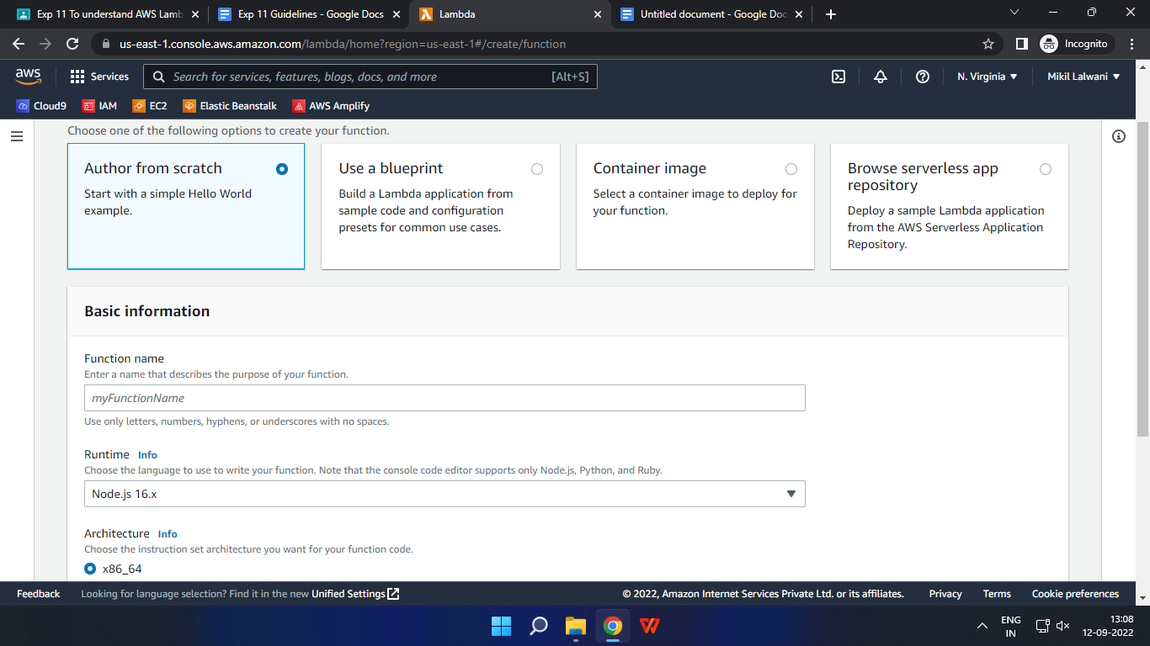

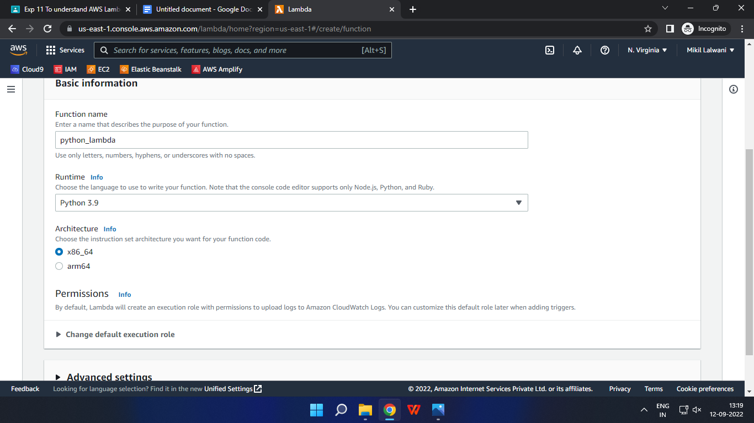

Click on the Create button.

1. This process will take a while to finish and after that, you’ll get a message that your function was successfully created.
2. To change the configuration, open up the Configuration tab and under General Configuration, choose Edit.

Here, you can enter a description and change Memory and Timeout. I’ve changed the Timeout period to 1 sec since that is sufficient for now.

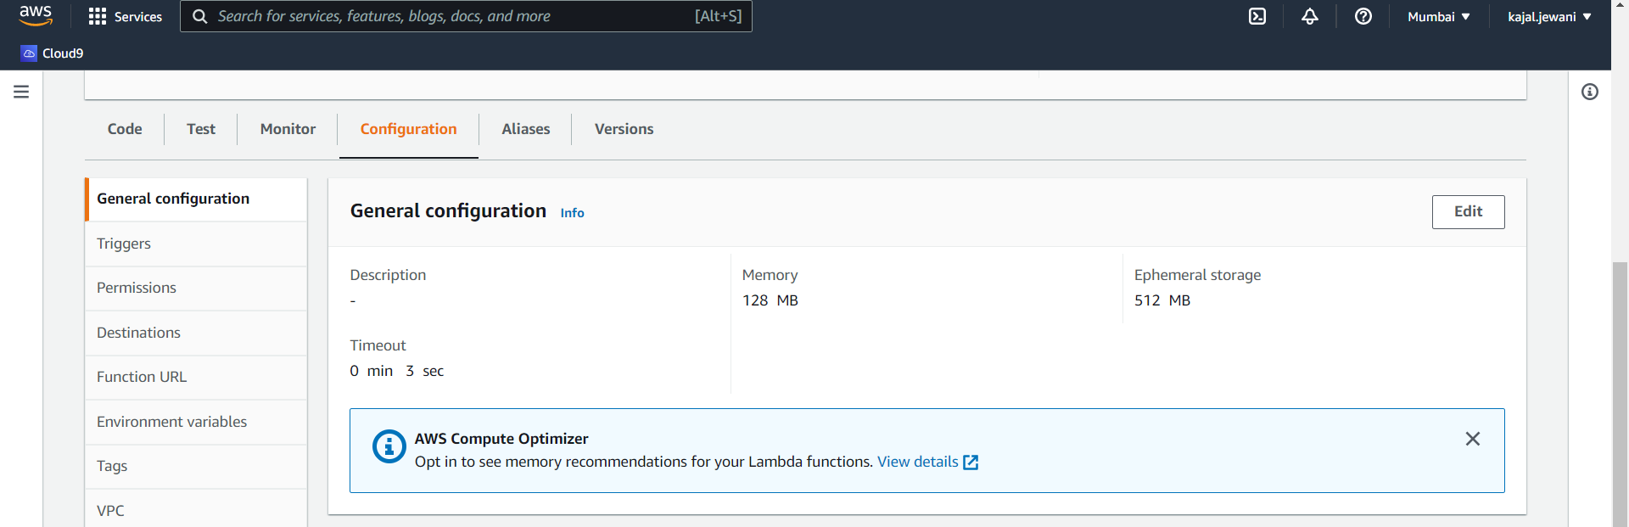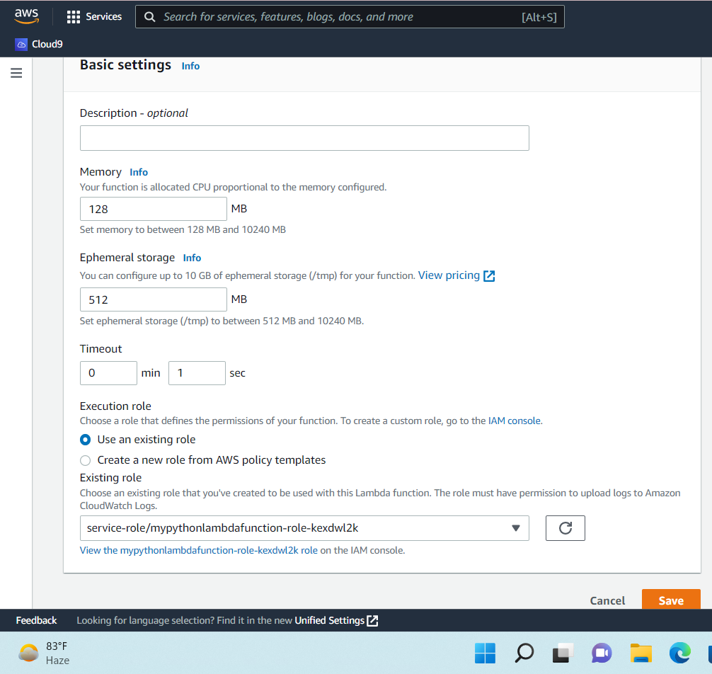

1. You can make changes to your function inside the code editor. You can also upload a zip file of your function or upload one from an S3 bucket if needed.

Press Ctrl + S to save the file and click Deploy to deploy the changes.

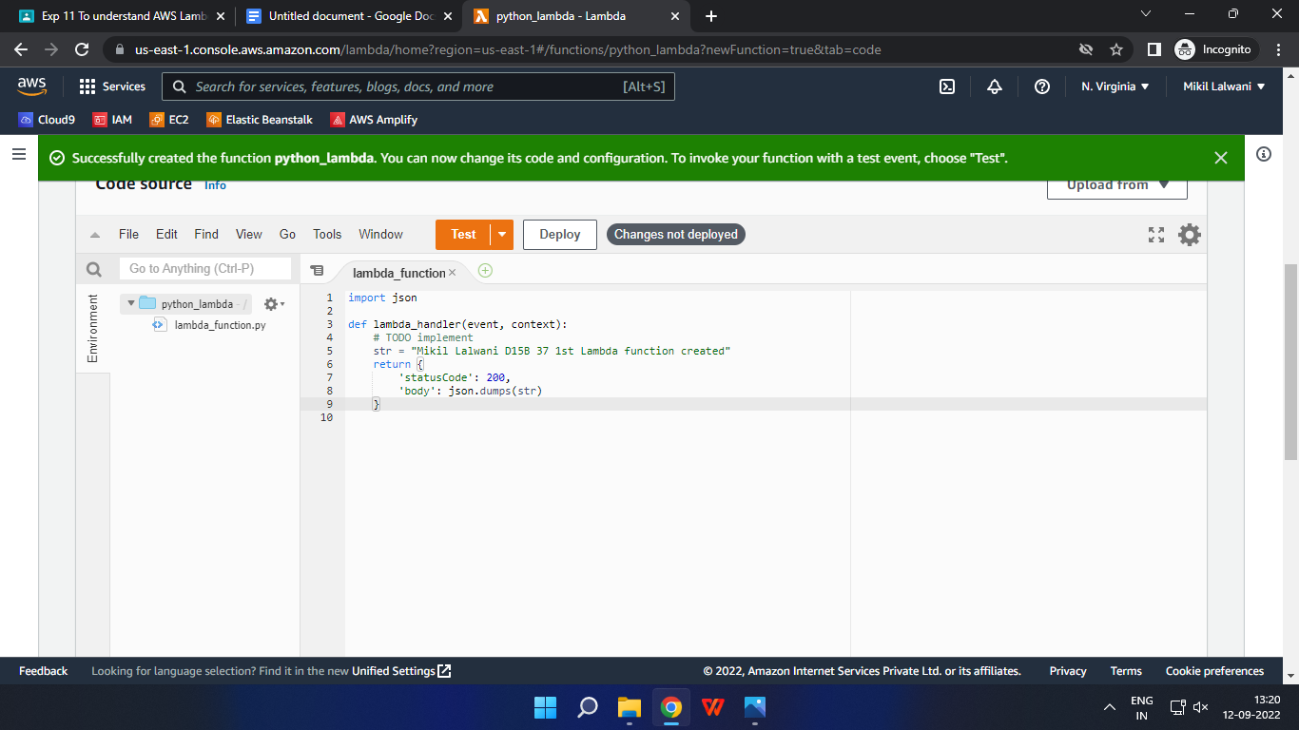

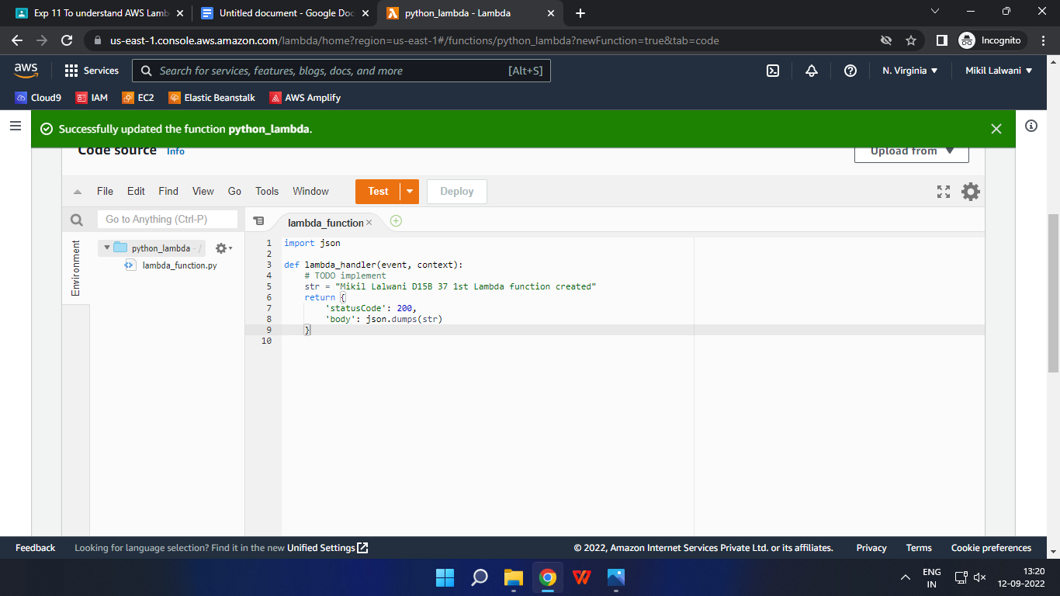

6. Click on Test and you can change the configuration, like so. If you do not have anything in the request body, it is important to specify two curly braces as valid JSON, so make sure they are there.

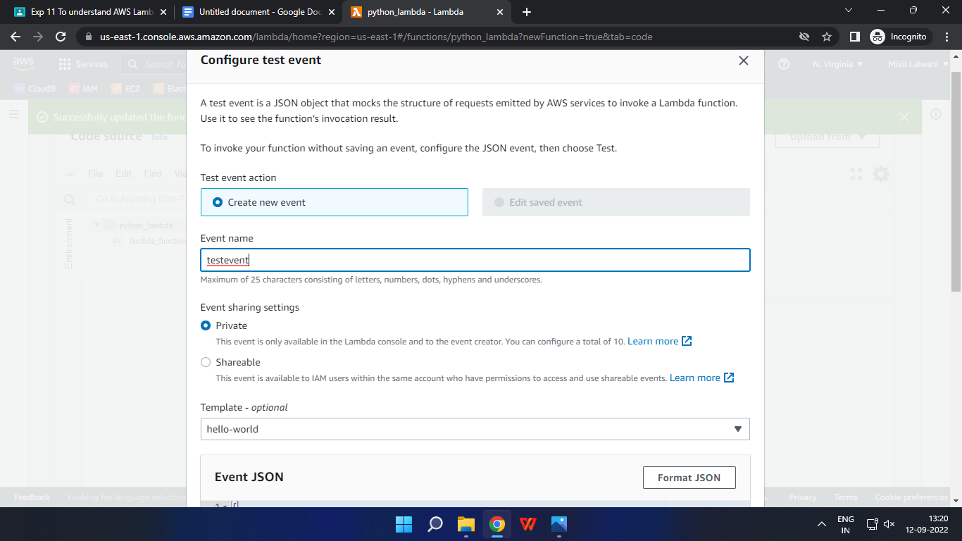

7. Now click on Test and you should be able to see the results.

